Chapter 21: Prevention of Disease Outbreaks

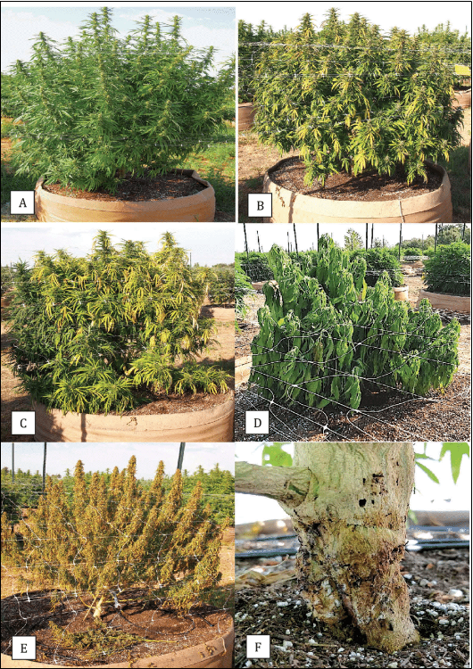
Figure 21.1. Cannabis plant with varying stages of disease susceptibility to crown rot.

The coming plagues: the cultural ecology of epidemics

In areas where the Cannabis economy has an historic presence it has already happened. Radiating outwards from cultivation hotspots, jumping towns via roads and airplanes, both familiar and once esoteric plant pests and pathogens are permeating all areas of Cannabis cultivation. These include common pests, such as the two-spotted spider mite, to the once rare broad, russet, and cyclamen mites or the more recent spread of the bhang aphid.
All of these insect and arthropod pests fuel the spread and growth of ever present fungal pathogens, such as bud rot (Botrytis cinerea) and powdery mildew (Erysiphales); as well as previously obscure (hopefully still so in your grow) pathogens in the genera Septoria, Fusarium, Colletotrichum, and Verticillium. Insect pests also vector plant viruses and bacterial pathogens. The expansion of Cannabis cultivation also brings cultivators into contact with previously covert, locally indigenous pathogens that emerge as “new” problems when confronted with the ecology of a Cannabis farm. Many microbes responsible for causing disease in Cannabis often go unidentified by farmers, obscuring the true scope of pathogens affecting the crop. Genuinely new associations may also evolve when pests and pathogens are presented with a novel potential host species.
Cannabis cultivation is coming out of the closet. Farms are getting bigger, more numerous, and more connected. Pest and pathogen problems that used to be limited by the fragmented and unconnected nature of cultivators operating in a black market are being replaced by an open and intensive economy with a web of physical interconnection. In some states the total number of growers may decrease if small scale and home cultivation is successfully discouraged by unfortunate regulations (i.e. Washington state, Quebec), but the overall scale and interconnectedness of Cannabis farms will invariably increase in all legal economies.
The emergence of legal and widespread cultivation of Cannabis as hemp ensures an increase in Cannabis cultivation regardless of how high-THC cultivation is regulated. Therefore Cannabis-philic pests and pathogens will continue to have increasingly more food available as well as increased ease of movement between these food resources. Monocropping of genetically identical clones, driven by a preference for clone-only Cannabis strains grown over large geographical regions, will exacerbate the emergence of resilient races of pests and pathogens.

Prevention of pathogens:
It is important to start clean whenever possible. Starting new gardens and farms from seed, rather than clones, can help reduce pathogen introductions and spread. All potential avenues for pathogen and pest introduction should be thoroughly evaluated for each farmer's unique situation (Table 19.1). Even seed may harbor pathogens, but strategies can be used to reduce this threat (Table 19.2). If clones are required, such as for the introduction of clone-only genetics, whole plant dips and quarantines should be used to reduce pathogen transfer at a minimum. Testing for the presence of known viruses and latent pathogens of particular concern should also be utilized whenever possible. Advanced tissue culture techniques may also be used to clear infected plants of a desired clone-only cultivar.

Table 21.1. Prevention of pathogen introductions is the first step to preventing disease outbreaks. Many sources for contamination of pristine grow rooms and locations can be identified and controlled. Alternatively, in areas where exposure to ambient inocula is inevitable (outdoors and most greenhouses), proper prevention and control strategies should be implemented before symptoms arise (integrated pest management). With vigilant prevention strategies, hopefully they never will.

Contamination source | Risks assessment | Mitigation
Clone market  · Clones are a primary source of pest/pathogen introductions | · Clones may bring along any biotic issue from the garden from which they originate along with them  · Long lived clone-only strains may accumulate viruses and latent endophytic pathogens | · Quarantine any new plant material  · Perform preventative treatments pests/pathogens  · Tissue culture may be used to clean contaminating pests, endophytes, and even viruses from plant tissue
Employee movement:  · Movement of pests within a grow and between grow areas at the same farm  · Often employees work at multiple farms  · Increased concern for indoor/year-round grows | · Trimmers are among the most promiscuous workers among farms  · All farm workers who make direct or indirect contact with plants pose a risk | · Separate trimming facilities; have clean room and areas separate from living plants.  · Have washrooms and work uniforms on site; incorporate hygiene protocol as a normal part of the job
Deliveries and vehicles:  · Vehicles can carry a lot of seeds, spores, and pests from one site to another | · Farm suppliers will be visiting more than your farm in their truck  · Service trucks (plumber, electrician, ISP) all will also be servicing other farms  · Employee and visitor parking | · Place parking lot as far from growing areas and intakes as possible  · If a vehicle is required for a job, wash it before allowing near grow areas  · Encourage/pay for off site employee car washes  · Have a car washing station away from grow areas and intakes
Tools and equipment | · Rental equipment should be assumed to be contaminated  · On-farm tools can spread pest/pathogens among plants and growing areas | · Wash rental equipment before use in growing areas  · Regularly clean and sterilize tools between growing areas  · Sterilize tools between use on different plants; this is critically important when moving between mother plants
Seed supplier | · Seed surface may be contaminated with pathogen (or beneficial) propagules  · Seed may internally harbor a pathogen (or beneficial symbiont) | · Surface sterilize seed  · Treat seed with known beneficials, possibly following seed sterilization  · Heat treatment of seeds may clear internal infections, but will greatly reduce seed viability

21.2 Cleaning seed for planting. Seed may be a source of microbial contamination, mostly on the outside surface though also sometimes inside the seed or even within the plant body itself.

 | Process | Pros | Cons
Surface sterilization | - 1.5 % v/v NaCLO for one minute.  - Rinse in sterile H2O  - Air dry seed on paper towels to plant immediately; Air dry at 30C 85F overnight (8-12hrs) for storage. | - No seed damage when performed directly prior to planting | - If performed before seed storage, it will reduce viability over time
Systemic fungicide sterilization | - Apply as directed on label | - Kills internally infested seed | - Systemic fungicides may persist  - Not organic  - None approved for use on Cannabis
Hot water treatments | - Preheat seeds to 38-43C (100-110F)  - Stir into 50C (122F) H2O* for 15-30 minutes  - Transfer to cool water immediately  - Air dry seed on paper towels to plant immediately; Air dry at 30C 85F overnight (8-12hrs) for storage. | - Kills internally infested seed | - Precise duration and temperature are unknown for Cannabis seed, and may vary based on seed characteristics (which can be highly variable among Cannabis varieties)  - Some seed is inevitably damaged.  - If performed before seed storage, it will greatly reduce viability over time
*Temperature must be accurate and precise throughout the treatment.

Disease pressure is often driven by planting intensity. In the Cannabis economy, this will manifest itself as increased density of farmers, intensity of crop cycles, and plant density within each farmer’s canopy. In areas where regulation of grow size is measured by canopy area rather than plant number, farmers will experience increased pressure to maximize canopy productivity thus encouraging higher density plantings and reducing interplanting options with alternate crops. This will lead to predictable agricultural problems associated with monocropping and crowded canopies. Regulators in such areas should take note and relax or reword canopy regulations to permit mixed crop plantings and increased spacing between plants. Unfortunately, even most current hemp regulations require plants intended to be sold in the same lot to be grown in contiguous areas.
Production farms are encouraged to eliminate downtime for any growing space, leading to practices such as perpetual cycles, intercropping, or immediate replanting following harvest. Additionally most modern Cannabis farms, particularly those that cultivate their cropped plants from cuttings, have a permanent vegetative area of mother plants. These cultivation practices allow for a “green bridge” for pests, allowing them a consistent food source and habitat. Working to eliminate the green bridge when possible can help break disease cycles and limit pathogen and pest damage.

Table 19.3. Break the “green bridge:” methods for eliminating carry-over pests from previous crops. The lifecycle of pest and disease organisms should be disrupted whenever possible to prevent continuation or amplification of pest problems the farmer may experience during a particular crop cycle. Perpetual growing styles increase the risk associated with pest accumulation, when compared to seasonal agriculture.
Outdoor/seasonal growers |  | Indoor/perpetual greenhouse
Rotate crops | - Plant alternative crops that cannot host pest organisms in between crop cycles  - Use Brassica plow under crops to treat field problems associated with Pythium, Fusarium, and Verticillium  - Reduce plant waste left in the field or work into top layer of soil allowing for quicker decomposition and pathogen antagonisms  - Hot-compost, heat-kill, or otherwise destroy pest containing plant debris | Maintain clean grow | - Filter incoming air  - Use positive pressure rooms to prevent unfiltered air leaks  - Require cultural practices for sterile rooms (clean clothes, shower areas, ect.)  - Clean grow areas periodically  - Consider avoiding perpetual grows in pest prone situations
Interplanting | - Interplant Cannabis with a diversity of other species  - Plant multiline seed with varying disease resistance  - Use Push/Pull repellant/trap plant system* | Environmental manipulations | - Take advantage of your control over the environment to make it unfavorable for your problem pests and pathogens
All cultivators
Grow from seed or clean, tissue-cultured plants | - Eliminate contamination from clones  - Eliminate the need for a perpetual mother area
Trap plants | - Use indicator and trap plants, such as calendula, to monitor and remove pests.
*Push/Pull companion planting uses plants which alternatively repel (push) or attract (pull) to direct plants pests away from the canopy (push plants interplanted into the canopy) towards pull plants (interspersed and along field edges). Pull plants can act as trap plants. Trap plants should be monitored as sentinels of pest invasions and are removed and destroyed before pests or pathogens can use trap plants as a food source for population growth. Precise plant combinations for Cannabis pests have not been researched. Mixing applied-plant-treatments with companion planting may simplify the system until effective planting combinations are specified. For instance, pest-attractive trap plants can be planted on the perimeter of a crop, then only the crop itself is treated with an appropriate pest deterrent (ie. essential oil product). Pests will prefer the still attractive trap plants to the treated crop, increasing the effectiveness of applied pest and pathogen treatments. Untreated Cannabis plants could be used as trap plants -just know they are destined for sacrifice, so don’t get attached and keep them too long.

Animal pests role in pathogen outbreaks:

Controlling arthropod and insect pests is an important component of limiting losses to fungal pathogens. These animals exacerbate fungal pathogens in several ways. Through their physical movement among plants and gardens plant pests may transmit spores or hyphae on their bodies. Additionally, chewing and sucking insects increase the plants vulnerability to pathogen attack by penetrating the plants physical protective barriers, or they may even directly vector pathogens into the body of the plant. In the case of viruses, most rely on vectors or fomites as their only method for gaining access to new plant bodies. Vectors are animals that carry and spread disease causing agents, whereas fomites are non-living objects, such as scissors, that may also introduce disease to a host organism.
Indirectly, animal pests increase loss to pathogens by leaving behind wounds and damaged or necrotic tissue that fungi may invade and exploit. Without these damage openings spores must otherwise germinate and overcome the physical defenses of the plant. Cannabis stems and older roots can develop a thick periderm (recognizable as bark among plants with intensive secondary growth). The epidermises of leaf tissue, young roots, and shoots is usually only a single cell layer thick. The leaf epidermis comprises dermal cells, trichomes, a waxy cuticle, and guard cells controlling the opening of stomata; root epidermis lacks guard cells and trichomes, but has specialized root hairs absent in above ground epidermis. Aside from guard cells, epidermal cells are usually transparent and devoid of chloroplasts.
In addition to the damage among plant tissue imposed by pests, their nutrient rich excretions are also a risk factor for subsequent attack by fungal pathogens. For Cannabis, this is particularly true for the necrotrophic pathogen Botrytis cinerea (Grey Mold). Necrotrophs are pathogens which actively kill living host tissue. By exploiting the nutrients in pest droppings, some pathogens may establish themselves on the plant surface before any plant tissue becomes susceptible to disease. This may permit the pathogen food resources it can leverage in order to mount an attack on living plant tissue.
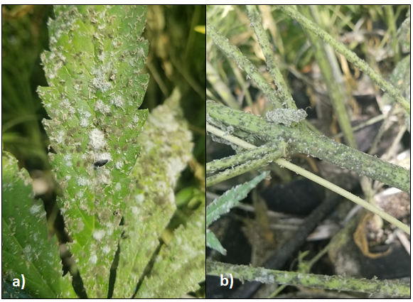
Figure 21.1. a. A leaf with powdery mildew (G. ambrosiae) colonies (white mycelium) interspersed among Botrytis colonies (grey) and black, sooty mold (Alternaria). b. Prolific botrytis growth on the stem is supported by aphid honey dew (excrement) well before the underlying plant tissue is susceptible to necrotrophic infection. Aphids and white flies infested this greenhouse planting, precipitating devastating mold epidemics. All of these mold varieties create prolific conidia which are moved by wind as well as on and inside insect bodies.

Clone Decay:
Genetic degradation in clones is a much talked about issue throughout the Cannabis industry. This is an issue that is not unique to Cannabis cultivation, and has come up frequently among mainstream agriculturalists. Among the agriculture industry broadly it is recognized that performance decline can indeed occur among clonally propagated plants. The primary causes of such declines are most probably an accumulated pathogen load (viruses, viroids, prions, bacteria and fungi), rather than genetic changes to the plant genome itself. However, reversible epigenetic changes or permanent mutations may occur in the DNA sequence itself (Jiang et al, 2011). Both epigenetic changes and mutations occur at higher rates among stressed plants (Jiang et al, 2014). Mutations also occur at higher rates among tissue cultured plants. See Chapter 10 for detailed information about epigenetics.

Clonal degradation: pathogen load, epigenetics, and somatic mutation

There is frequent discussion within the Cannabis industry about the loss of vigor among long lived, clone-only lineages. This is not an issue unique to Cannabis. In fact many crops are propagated clonally from highly desirable, elite individuals (McKey 2009, Otfinowski et al. 2016). This includes many fruit crops (grapes, apples, citrus, blueberries, ect.), as well as most root tuber crops (potatoes, sweet potatoes, sunchoke, cassava, yams), and nearly all perennial ornamentals. There has long been debate about the causes of such deterioration within lines. Some have argued it is caused by a breakdown of genetic material or an accumulation of somatic mutations (often incorrectly referred to as “genetic drift,” which is an entirely different phenomenon where allele frequency changes over generational time amongst a population due to random chance, rather than selective pressure). Changes in phenotype can occur following somatic mutations; distinct phenotypes that emerge in this way are referred to as sports. However, it is now believed that the more likely causes of most observed ‘clonal-degradation’ are not usually due to changes in the genetic sequence. Rather an accumulation of deleterious viruses, viroids, and prokaryotic and fungal pathogens are primarily responsible for loss of clone vigor. It should be noted that some of these accumulated, deleterious “pathogens” may have once served their host mutualistically as endophytes under a set of conditions it had experienced in the past -or could again in the future (Rodriguez et al. 2009). Recently, the causal agent of the phenomenon known as “dudding” has been identified to be hop latent viroid (Warren et al, 2019).
In addition to somatic mutation in the plant genome itself and accumulated pathogen load, epigenetic changes may also be induced during a plant's lifetime as a result of environmental effects. Epigenetics is the field of biology that studies how genes are differentially expressed among different cells that contain the same genome. Epigenetics, literally meaning “on” or “above” genetics, refers to the alteration in the expression of a plant's DNA rather than changes to the code sequence itself. Epigenetic control of gene expression is what permits genetically identical cells to differentiate in order to perform specialized functions within the same organism. Differential expressions of genes is a necessary process for the development of specialized tissues in complex organisms. Epigenetics may also create semi-persistent alterations to gene expression that last multiple generations.

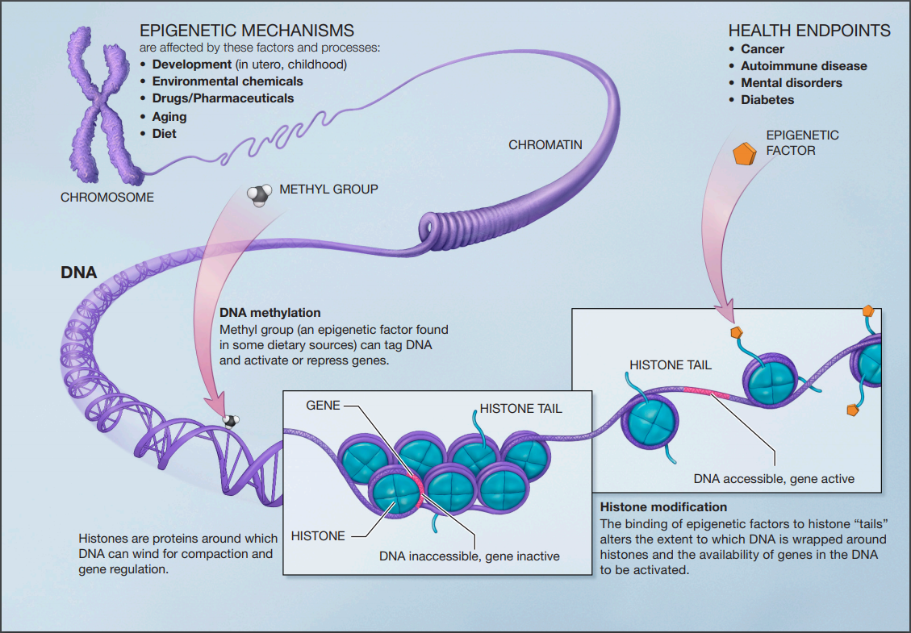
Figure 5. Epigenetic changes to DNA are likely transmitted by histone tails or DNA methylation added to activate or repress the expression of certain genes. (National Institutes of Health).

Gene expression is altered in this way by the methylation of the DNA itself, or by various modifications to histones, specialized proteins around which DNA molecules are “packed” and organized (Allis and Jenuwein 2016). These modifications can act as gatekeepers for transcription;specific alterations prevent or allow RNA polymerase and transcriptional cofactors access to specific regions of the genome. If a gene is available to the cell machinery for transcription, messenger RNA may be produced. This messenger RNA, once edited of introns, exits the nucleus into the cell cytoplasm where it then may be translated into a protein. There are numerous other mechanisms of gene regulation after translation occurs. While most epigenetic alterations that occur during an individual's lifetime are removed from its gametes during gametogenesis, a minority may persist for several generations, a phenomenon known as transgenerational epigenetic inheritance (Allis and Jenuwein 2016).
Tissue culture techniques may be used to clear deteriorating clonal lines of accumulated endophytes, viroids, and viruses, as well as possibly resetting some of the induced epigenetic changes by inducing a juvenile plant stage. Therefore the persistence of epigenetic changes in tissue cultured plants may be less stable than in seed propagated plants (Smulders and Klerk, 2011). Tissue cultured plant tissues are more susceptible than mature plants to the development of permanent genetic mutations, resulting in somaclonal variants.
Epigenetic changes may also serve as the basis for the transformation of alleles in the case of paramutation. Paramutation is the ability of an allele to induce an heritable transformation of a corresponding allele at the same locus when present in an organism in a heterozygotic state. Though the DNA sequence is not changed in the transformed allele, epigenetic modifications induced by the corresponding allele result in both alleles expressing themselves as the ‘infectious’ paramutable variant in the current and subsequent generation.

Epigenetic aspects of somaclonal variation in plants

To clear tissues of internal passengers, explants should consist of the smallest section of tissue possible. The apical meristem, not yet connected to the vascular system, should be targeted to exclude viruses which are less likely to have infected this region of a plant. This may take several rounds of cloning.

Epigenetics:
Epigenetics refers to heritable traits that are unexplained by alterations in the DNA sequence itself. In popular usage, the term is often used to refer to culturally inherited characteristics, traditions, and knowledge that operates “above” (i.e. epi-) the level of genetics: a force acting to affect human phenotypes across generations, but independent of the hereditary molecule, DNA. But the epigenetics as discussed in biology is not unique to humans, and is not dependent on culture.
Epigenetics changes are the result of real, physical changes in the structure, though not sequence, of DNA and the histone proteins around which it is packaged. These physical changes are the methylation of DNA or variously complex modifications of histones (usually methylation and acetylation). These physical changes to the DNA molecule and their packaging proteins results in persistent alterations in gene expression. This is a major mechanism controlling gene expression which permits the specialization of cells and the formation of tissues in complex, multicellular organisms. Among humans, cultural epigenetics, including nutrition and lifestyle, may induce physical epigenetic changes in individuals characteristic of those cultural environments (Jablonka, 2016). In some cases these induced epigenetic changes may reinforce the culture which induced them, leading to a positive feedback loop.
Histone modifications and DNA methylation act to “expose” or “protect” certain areas of the DNA (Allis and Jenuwein, 2016). If exposed, the cellular machinery responsible for possible transcription of a DNA sequence into RNA may access the gene. This is the first step in possibly expressing the phenotypic information contained in a gene. Various downstream post transcriptional and post translational regulation may ultimately prevent a transcribed gene from being expressed as a phenotype. Epigenetic mechanisms can be relatively persistent gene switches. In fact, epigenetic modifications can be so persistent that some may survive the chromatin remodeling which occurs during gamete formation to persist generations removed from the parent generation in which it was induced (Henderson and Jacobson, 2007).

